King Fahd University of Petroleum and Minerals
Information and Computer Science Department

ICS 103: Computer Programming in C
Summer Semester 2008-2009 (Term 083)

Final Exam

Time: 150 minutes Tuesday, September 1, 2009, 9:00 PM

Name:
ID#:

PLEASE CIRCLE YOUR SECTION BELOW:

Section | 1 | 2 | 3
Time | SUMT 8:10-9 | SUMT 9:20-10:10 | SUMT 9:20-10:10

Note:

- Copying or Discussion will result in zero grade for all the students involved.
- Attempt all questions.

Question # | Maximum Marks | Obtained Marks
1 | 30
2 | 30
3 | 16
4 | 24
Total | 100

Good Luck

Question 1: (30 points)

Find the output of each of the following programs. Show your work.

Program | Output
- 6 points

#include <stdio.h>

int test (int x[],int s,int e, int t) {
int m;

if (s > e) return -1;
m=(s + e)/2;
if (x[m] == t) return (m);
else if (x[m] < t)
return test(x,m+1,e,t);
else return test(x,s,m-1,t);
}

int main(void) {
int x[]={1,5,10,20,32,50};

printf("%d\n",test(x, 0, 5, 32));
return 0;
}
6 points

#include <stdio.h>

void test2(int a[], int n) {
int i, j = 1, k, l;

do{
k = 0;
for(i = 0; i < n - j; i++) {
if (a[i] < a[i+1]) {
l=a[i];
a[i]=a[i+1];
a[i+1]=l;
k = 1;
}
}
j++;
} while (k && j <= n-1);
}

int main(void) {
int x[]={10,5,20,15};
test2(x, 4);
for (int i=0; i<4;i++)
printf("%d ",x[i]);
printf("\n");
return 0;
}

- 6 points

#include <stdio.h>
#include <string.h>
#include <ctype.h>

void test3(char a[]) {
for (int i=0; i<strlen(a);i++)
a[i]=tolower(a[i]);
}
void test4(char a[], char b[], int n) {
for (int i=0; i<n;i++)
b[i]=a[i];
}
int main(void) {
char str1[]="Ahmad is Tall", str2[]="MAD", str3[strlen(str2)];
int i,nf=1;

test3(str1);
test3(str2);

for(i=0;i<strlen(str1)&&nf;i++){
test4(&str1[i],str3,strlen(str2));
nf=strcmp(str3,str2);
}
if (nf) printf("No\n");
else printf("Yes\n");
return 0;
}

- 6 points

#include <stdio.h>

#define size 3

int main(void) {
int A[size][size]={{1,2,3},{4,5,6},
{7,8,9}};

for (int i=0; i<size;i++){
for (int j=0; j<size;j++)
printf("%d ",A[j][i]);
printf("\n");

}
return 0;
}

- 6 points

#include <stdio.h>

int main(void) {
int i;

for (i=0; i<10; i++) {
printf("\n%d ", i);
if (i < 5)
continue;
printf(" * %d", i);
if (i > 8)
break;
}
printf("\n");

return 0;
}

Question 2: (30 points)
You are required to write a C program to read a two dimensional array of integers, exchange two rows, exchange two columns and display the array after being read and after each exchange. In your solution, you are required to do the following:
- Ask the user to enter the number of rows and columns in the array and read them. Assume that the maximum array size is 10x10.
- Write a function to read a two-dimensional array and use it to read the array.
- Write a function to display a two-dimensional array and use it to display the read array.
- Write a function to exchange two rows in the array.
- Write a function to exchange two columns in the array.
- Display a menu for the user asking him to select a choice between exchanging two rows, exchanging two columns or exit the program. The menu should be displayed repeatedly until the user chooses to exit the program. If an incorrect choice is entered, the message “Invalid choice !!” should be displayed.
A sample execution of the program is shown below:

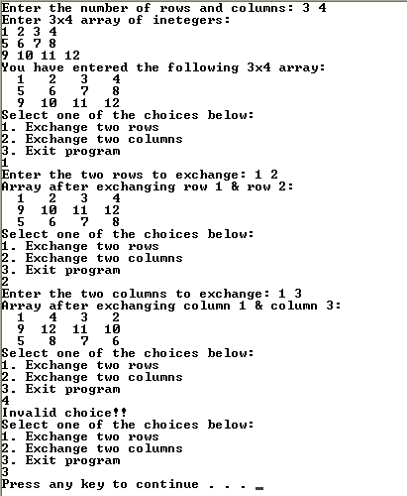

Question 3: (16 points)

You are required to write a C program to do the following:
- Ask the user to enter a list of names and read them. The end of the list is indicated by the user hitting the enter key. Display the number of names entered. Assume that the maximum number of names to be entered is 40 names and the maximum name length is 80 characters.
- Ask the user to enter a name to search for in the list. Print whether the name is found or not.
A sample execution of the program is shown below:

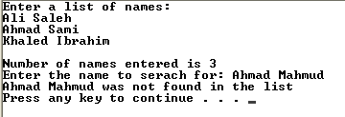

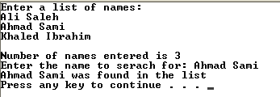

Question 4: (24 points)

- Write a function that converts Cartesian coordinates to polar coordinates. That is, given x and y, the function should calculate and return r and  as given by
and 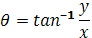
Hint: use atan2(y, x) to calculate 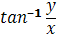.

- Write a function that takes a string as an argument and returns the number of words in the string (assume words are separated by white spaces). For example, the string “C is a programming language” has 5 words.

- Write a function that takes a square matrix as an argument and tests whether it is diagonal or not. The functions should return 1 if the input matrix is a diagonal and 0 otherwise. Hint: a diagonal matrix is a square matrix in which all elements outside the main diagonal are zeros. But the diagonal elements may or may not be zeros.

